**Construction of CSR Case under GPM Sustainability Methodology**

**Advance 2: Impact Analysis applying The GPM P5TM Standard and Development of a preliminary Sustainability Management Plan**

**Content of the document**

**Cover and index (5%)**

**Introduction (5%)**

About the task, what it consists of, its practical importance, the objectives, brief description of the methodology and the theoretical framework.

**Development: (60%)**

**Phase I: Impact Analysis applying the P5TM Standard**

**Triple Base Line**

**1.1 Development of the baseline according to GPM methodology. (15%)**

John Elkington, introduced a new measurement standard from the triple baseline in the mid-1990s. In this way, the valuation of a company goes beyond the metrics of profit and present value to incorporate social and environmental metrics. Looking ahead, it should become an aspect to consider in the analysis of the value of a company in the stock market, given that it provides a long-term valuation factor.

The challenge is to properly define the unit of measurement of social and environmental variables, and how to assign them an appropriate value, which are not easy tasks.

The reality is that there is no single method to calculate the TBL (Triple Baseline) but it will depend on the context of the project and its objectives, and the definition of its units of measurement. It also poses a challenge when it comes to collecting necessary and recurring information to achieve these metrics.

Therefore, the initial participation of the stakeholders is important to define the units of measurement that are considered most representative for the company and for each project, at the social and environmental levels, in order to construct a representative TBL.

**To develop this item, it is necessary to study the P5 Standard**, and then define qualitative or quantitative sustainability indicators, according to the elements defined in each of the social, environmental and economic subcategories and categories. They should define those that are pertinent to your project. See the next figure.

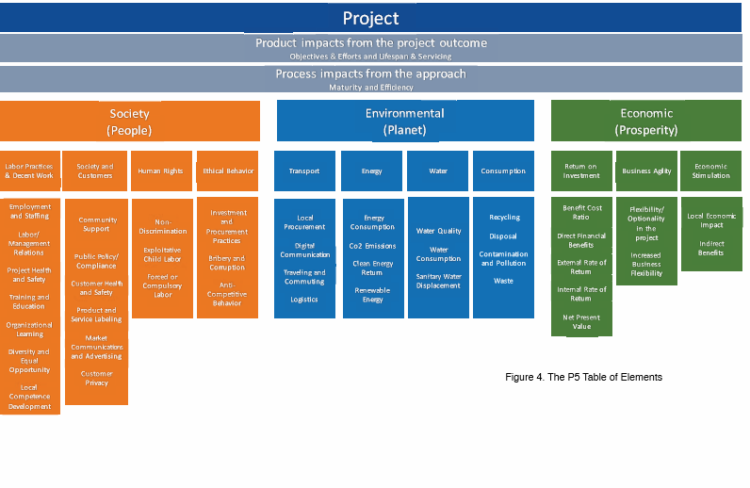

Example 1:

Elements for the Triple Baseline of the project to improve a national park.

|  |  |
| --- | --- |
| **Financial** | Average cost / square meter of land purchased vrs square meter cost of the market |
| Square meters acquired / total square meters of the project (project progress) |
| % Loan backed by funds contributed by members of the organization or Social Capital |
| Annual growth rate of the organization's income |
| Annual Operating Cost Growth Rate |
| Net profit |
| **Social** | Growth of protected water supply sources for the region's community. |
| Result per survey of incentive plan by landowners who have sold to the Park. |
| Additional income for the community by tourism that visits the National Park |
| Feeling of community participation in the project (survey) |
| Growth in environmental education in the community (survey) |
| **Environmental** | Protected square meters / square meters of the project |
| Variation in annual river flow as a result of the park  (Unit of measure of the flow) / Recharge of aquifers |
| Measurement of contributions to Carbon Neutrality project |
| Improvements in the environment by greater protection of water resources (flora and fauna of the area) |
| Level of air pollution in the region |
| Decrease in dry and grazing areas |

**How to perform a P5 Impact analysis?**

According to Standard P5 (2014), there are several ways for performing a P5 impact analysis. The development of a risk register, using each element as a category, is the simplest. The most effective way is to use a scoring system. When using a scoring system, each deliverable and project process scores on each P5 element based on a positive / neutral / negative scale, ranging from neutral (0), high (+ 3) , Medium (+ or -2), and low (-3). The lowest value is equal to the lowest impact (-3 for example, is the best possible score).

Impact analysis P5 provides key information on where problem areas are from the perspective of sustainability.

**Phase II: Development of the preliminary Sustainability Management Plan**

**Description of the deliverable**

Once the P5 Analysis has been carried out in phase 1, each group must develop the Sustainable Management Plan in a preliminary manner. The template below and the results of the impact calculator on the triple baseline should be used. Justify your arguments and assumptions in a clear, direct and simple way.

Introduction, general and specific objectives (of the deliverable)

**Development: (45%)**

Parts of the Sustainability Management Plan are:

1. Document control
   1. Revision history
   2. Distribution of the document
2. Purpose of the document
3. Executive Summary

In the Executive Summary, describe the problem, how it is proposed to solve it, and comment on the results of the impact analysis, explain the following graphs:

* Global Project Impact on TBL.
* Impact of the goals and objectives on the TBL.
* Impact of deliverables on TBL.
* Impact of processes on TBL.
* Impact of resources on TBL.

1. Sustainability objectives
2. Key metrics and performance indicators (qualitative and quantitative measures)
   1. Key environmental performance indicators
   2. Key indicators of financial performance
   3. Key indicators of social performance
   4. Key Product Performance Indicators
   5. Key performance indicators for processes
3. Ethical behavior: Estimating environmental impact

Summary of planned environmental impacts and the strategy to reduce negative effects or increase opportunities. These concepts and values ​​are entered in the input box of the "impact calculator". Negative risks (threats) are represented by positive values, and positive risks (opportunities) are represented by negative values.

|  |  |  |  |  |  |  |
| --- | --- | --- | --- | --- | --- | --- |
| P5 Category | P5 Sub category | P5 Element | Environmental impact | Estimation /  signification | Legal Regulation | Environmental Plan |
| Environment | Transportation | Transportation | Excessive use of fossil fuels during travel | +3 / high demand for fossil fuels implies increased oil extraction and environmental deterioration, in addition to increased pollution and financial expense. |  | Use of low-capacity, low-consumption or electric vehicles |

1. Exclusions in Scope: Explain which known aspects will not be part of the project.
2. Management of sustainability risks

|  |  |  |  |  |  |  |  |  |
| --- | --- | --- | --- | --- | --- | --- | --- | --- |
| Cause | Name of the risk | Risk Description | Objective impacted | Probability (P) | Impact (I) | PxI | Strategy | Actions |

1. Reviews and reports: Propose how you will report on compliance with sustainability objectives, indicators, the status of risks or the appearance of new risks, or other information about the status of the project within the framework of the sustainability impact, its frequency, who is responsible, who receives the report and through what medium.
2. Checklist

**Conclusions (of deliverables) 10%**

**Recommendations (of deliverables) (10%)**

**Bibliography (5%)**

**Attachments**

N ° 1. Charter (of the deliverables) (5%)