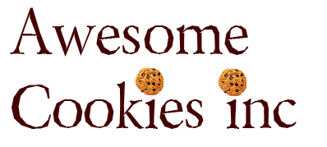

**Brief:**

We have been hired in to save Awesome Cookies Inc.

Awesome Cookies Inc. has no project management standards or methodology. The average staff person however has been employed within the company for 15 years. Their CEO recently was caught in a scandal and they have been listed as one of the most wasteful companies in terms of production and distribution and sales are declining.

**Core Problems:**   
  
Unless their core product, “The Ultimate Choco-Cookie” can be redeveloped from the ground up to become a more sustainable product, they may have to close operations

It is rumoured that ingredients in the cookies are not accurately reported on the labels and blogs and YouTube videos have popped up with consumers complaining.

Distribution has been difficult, as the taxes in Athens have skyrocketed due to the economic challenges in Greece.

Their CEO passed away unexpectedly and so the executive board has hired our management-consulting firm to guide them towards a new and brighter future.

**As the future of their brand and company rests in our hands, we are to recommend a project-based strategy to turn this company around:**

In your team, appoint a project manager and a communications lead.

1. Perform a SWOT analysis to determine how many projects your project team can identify
2. Based on which project you are assigned, develop a high level statement of work for your project.
3. Use P5 to measure Impact based on what we already know about their products and supply chain and recommend changes through the development of an SMP.

**Company Name:** Awesome Cookies Inc.  
**Headquarters:** Beirut Lebanon

**Plants:** Athens- Greece, Beirut-Lebanon, Madrid-Spain,

**Products:** Cookies.

**Data Sheet: The Cookies**

**Things to consider**

**All cookies are individually wrapped for distribution, and sold individually.  
Nothing regarding the cookie is off limits.**

**Ingredients**  
ENRICHED FLOUR (WHEAT FLOUR, NIACIN, REDUCED IRON, THIAMIN MONONITRATE [VITAMIN B1], RIBOFLAVIN [VITAMIN B2], FOLIC ACID), SEMI SWEET CHOCOLATE (SUGAR, CHOCOLATE, COCOA BUTTER, SOY LECITHIN, NATURAL FLAVOR), SUGAR, VEGETABLE OIL (SOYBEAN, PALM, AND PALM KERNEL OIL WITH TBHQ FOR FRESHNESS), CONTAINS TWO PERCENT OR LESS OF MOLASSES, SALT, EGGS, BAKING SODA, NATURAL AND ARTIFICIAL FLAVOR, WHEY, WHEY PROTEIN CONCENTRATE.

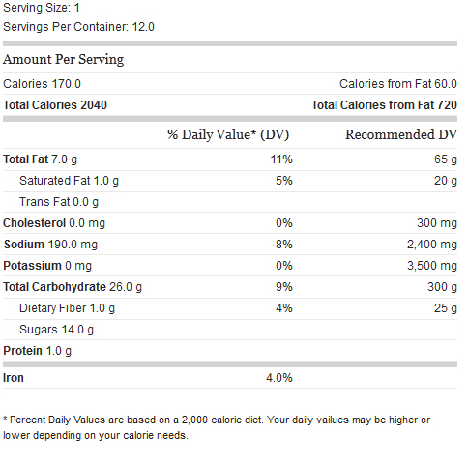**Allergen Information**  
Eggs, Milk, Soy, Wheat

**Company Name:** Awesome Cookies Inc.  
**Headquarters:** Beirut Lebanon

**Distribution Center:** Athens, Greece

**Products:** Cookies.

**Data Sheet: Distribution**

**Things to consider**

* **All cookies are individually wrapped for distribution, and sold individually.**
* **The Athens Bakery is the only distribution center.**
* **Nothing regarding the distribution or operations is off limits**

**Primary Customers:**

* Wholesale distributors
* Chain Grocery Stores
* Vending Companies
* Convenience Stores

**Service Output**

Sells Products in highly competitive markets  
Inefficient Product Distribution Network - three plants and eight Distribution Facilities

**Cost to Profit Ratio**  
.75 to make  
1.00 msrp  
.25 Profit

**Market Share**  
They have a strong presence in the Mediterranean but globally are dwarfed by Nestle and Kraft.